The Golden Years: 1924-1928 Date:
WILF: To examine what was life like in the Weimar Republic between 1924 and 1928

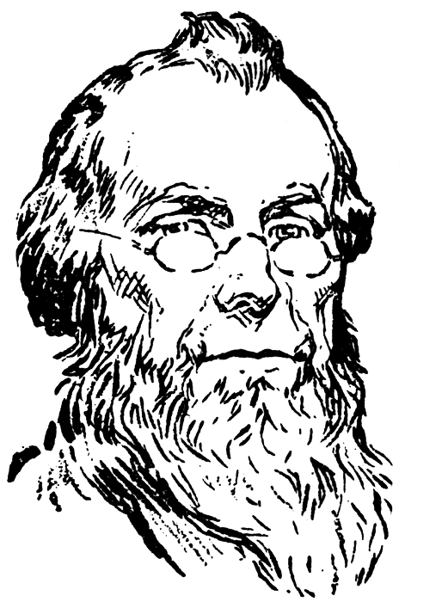
I remember the Golden Age of the Weimar Republic well!
It was… ________________________________________________________________________________________________________________________________________________________________________________________________________________________________________________________________________________________________________________________________________________________________________________________________________________________________________________________________________________________________________________________________________________________________________________________________________________________

